Tutorial- 02

Name : Ranudi Gayathmie Kariyapperuma
Index : 29897
Batch No : 23.1
Degree Program Name : Technology Management

- How do you write comments in a c program? What is the purpose of comments in a program?

- Single comment - ex :- // comment
- Multiline comment – ex:- /* comment*/

- The purpose of comments is that when a programmer code the program and if it needs to see by other programmer then he or she can easily identify the codes that are used in the program by using comments.

- Which is the function that is essential in a C program?

- Main Function is the essential function in C program.

- What is the purpose of ‘scanf’ ?

- Scanf function is used to take input from the user.

- Is ‘standard c’ a case sensitive language?

- Yes, it is a case sensitive language. In c language we always have to use correctly if we write in lower case all should have to be lower case .

5. Determine which of the following are valid identifiers. If invalid, explain why.

(a) record1 - Valid
(b) 1record - Invalid . Because A variable cannot start with a Number.
(c) file-3 - Invalid. Because it can’t have special characters like “ –“ it is
incorrect
(d) return - Valid
(e) $tax - Invalid . Because a variable cannot have special characters.
(f) name - Valid
(g) name and address - Invalid. Because a variable name cannot have keywords and spaces.
(h) name-and-address - Invalid . Because cant use special characters .
(i) name_and_address – Valid
(j) 123 - 45 - 6789 - Invalid . Because variable can’t start with numbers and also cant
use Special characters.

- State whether each of the following is true or false. If false, explain why.

- Function printf always begins printing at the beginning of a new line.

- False .

- Printf function doesn’t print at the beginning of a new line its print when ever the cursor begins.If you need to get a new line you have to write the code with “\n” this is called as line breaker.

- Comments cause the computer to print the text enclosed between /* and */ on the screen when the program is executed.

- False

- These comments doesn’t show when a program is executed. Comments are used for programmers to identify the coding parts easily.

- The escape sequence \n when used in a printf format control string causes the cursor to
position to the beginning of the next line on the screen.

- True

- All variables must be defined before they’re used.

- True

- All variables must be given a type when they’re defined.

- True

- C considers the variables, number and NuMbEr to be identical.

- False

- number and NuMbEr should be same in the C language because C language is a Case sensitive language . So The both should be in lower case or uppercase if not they will be incorrect.

- A program that prints three lines of output must contain three printf statements.

- False

- No need of three lines of printf statements to get three line of output in one printf statement can get three lines of outputs by using “\n” line breaker.

- What does the following code print?

printf( "*\n**\n***\n****\n*****\n" );

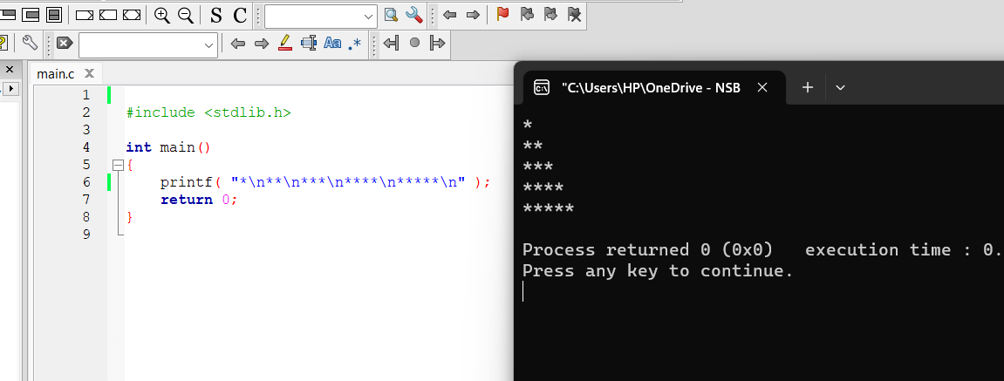

- Identify and correct the errors in each of the following statements. (Note: There may be more than one error per statement.)

- scanf( "d", value );

- scanf ( “%d”, &value);

- printf( "The product of %d and %d is %d"\n, x, y );

- printf( "The product of %d and %d is %d \n” x, y );

- Scanf( "%d", anInteger );

- Scanf( "%d", &anInteger );

d) printf( "Remainder of %d divided by %d is\n", x, y, x % y );
- printf( "Remainder of %d divided by %d is %d \n" x, y, x % y );’

- print( "The sum is %d\n," x + y );

- printf( "The sum is %d \n" x + y );

- Printf( "The value you entered is: %d\n, &value );

- printf( "The value you entered is %d \n” ,value );

- What, if anything, prints when each of the following statements is performed? If nothing \prints, then answer “Nothing.” Assume x = 2 and y = 3 .

- printf( "%d", x );

- 2

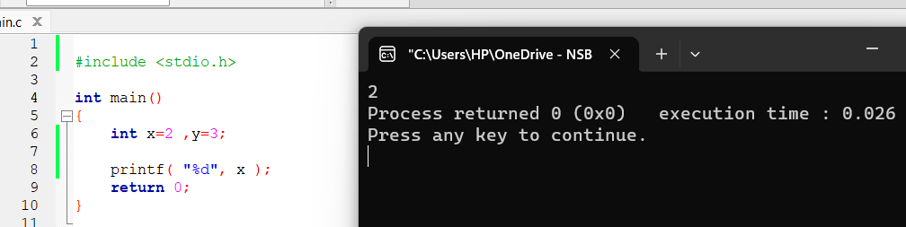

- printf( "%d", x + x );

- 4

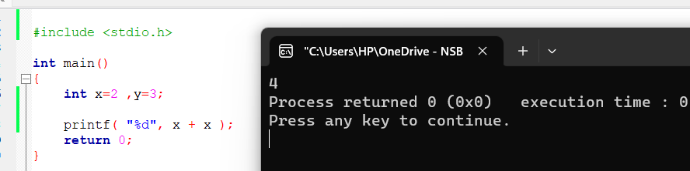

- printf( "x=" );

- x=
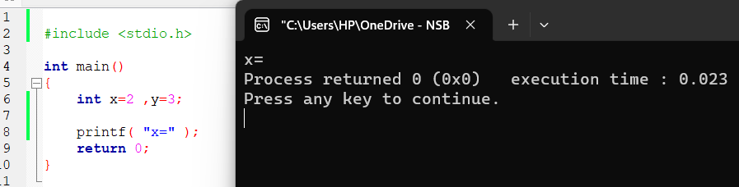

- printf( "x=%d", x );

- x= 2

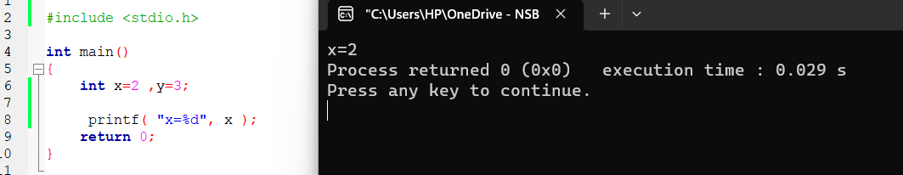

- printf( "%d = %d", x + y, y + x );

- 5=5

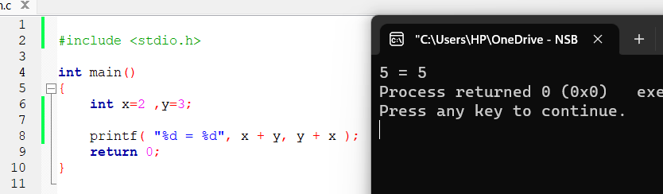

- z = x + y; = Nothing

- scanf( "%d%d", &x, &y ); = Nothing

- /* printf( "x + y = %d", x + y ); */ = Nothing

i) printf( "\n" ); = Nothing

- State which of the following are true and which are false. If false, explain your
answer.

- C operators are evaluated from left to right.

- False
- C operators are not always evaluated from left to right These are evaluated from precedence and associativity.

b) The following are all valid variable names: _under_bar_ , m928134 , t5 , j7 , her_sales
his_account_total , a , b , c , z , z2 .

- True

c) The statement printf("a = 5;"); is a typical example of an assignment statement.

- False .
- It is not a assignment statement. If it is a assignment statement there must not be a printf statement.

d) A valid arithmetic expression containing no parentheses is evaluated from left to right.

- True

- The following are all invalid variable names: 3g , 87 , 67h2 , h22 , 2h

- False
- Only 3g,87,67h2,2h are invalid variable names .

